PROJECT REPORT OF INDUSTRY ORIENTED HANDS ON EXPERIENCE (IOHE)
ON
Code Craft
submitted in partial fulfilment of the requirements for the award of degree of

BACHELOR OF ENGINEERING
In
COMPUTER SCIENCE AND ENGINEERING

Submitted by: Supervised By:
Shashi Kumar (2210992289) Mrs.Preeti Saini
Nikhil (2210991977) Professor,
Nikhil Kaushal (2210991980) Department of Computer Science
Shitij Kalia (2210992300) and Engineering

DEPARTMENT OF COMPUTER SCIENCE AND ENGINEERING

CHITKARA UNIVERSITY INSTITUTE OF ENGINEERING AND TECHNOLOGY
CHITKARA UNIVERSITY, PUNJAB, INDIA

CONTENTS

S.No. | Title | Page No.
 | Acknowledgement | 4
 | List of Figures and Tables | 4
 | Abstract | 5
1 | Introduction | 6-7
2 | Methodology | 8
3 | Tools and Technologies | 9
4 | Implementation | 10-11
5 | Major Findings/Outcomes/Output/Results | 12-15
6 | Conclusion and Future Scope | 16
 | References | 17
 | Appendices | 18

DECLARATION

I hereby certify that the work which is being presented in the project report entitled Code Craft in partial fulfilment of requirement for the award of the degree of Bachelor of Engineering (Computer Science and Engineering) submitted in the department of Computer Science and Engineering at Chitkara University Institute of Engineering and Technology, Chitkara University, Punjab, India, is an authentic record of my own work carried out under the supervision of Mrs.Preeti Saini.The matter presented in this project report has not been submitted in any other university/institute for the award of any degree.
Shashi Kumar(2210992289)
Nikhil(2210991977)
Nikhil Kaushal(2210991980)
Shitij Kalia(2210992300)

Place: Rajpura
Date: ……………..

This is to certify that the above statement made by the candidate is correct to the best of my knowledge and belief.

Mrs.Preeti Saini
Professor, Department of Computer Science and Engineering
Department of Computer Science and Engineering
Chitkara University Institute of Engineering and Technology,
Chitkara University, Punjab, India

ACKNOWLEDGEMENT

We express our sincere gratitude to our supervisor, Dr. Preeti Saini, for her invaluable guidance, continuous motivation, and constructive feedback throughout the development of this project. Her expertise in software engineering and full-stack development greatly enriched the quality of our work.

We also thank the Department of Computer Science and Engineering, Chitkara University, for providing the necessary infrastructure and academic support. Special thanks to our peers and family members for their encouragement.

LIST OF FIGURES AND TABLES

Figure/Table No. | Title | Page
Figure 1 | System Architecture Diagram | 9
Table 1 | Technology Stack | 7
Table 2 | Test Results Summary | 10

ABSTRACT
Code Craft is a full-stack web-based personality prediction system designed to overcome the limitations of traditional, static personality assessment methods. The platform offers secure user authentication, interactive quiz-based evaluation, real-time result generation, and responsive cross-device compatibility. Built using the MERN stack (MongoDB, Express.js, React.js, Node.js), the system processes user responses through intelligent scoring algorithms to produce meaningful personality trait insights. The project demonstrates a practical, scalable, and privacy-aware implementation of digital personality assessment, benefiting individuals in self-awareness and organizations in recruitment screening.

- Introduction
1.1Problem Background
Personality assessment plays a critical role in understanding individual behavior, emotional intelligence, and decision-making abilities. Traditional methods such as paper-based questionnaires and static online forms are often time-consuming, lack user engagement, and fail to provide adaptive or intelligent analysis. Moreover, many existing platforms do not ensure adequate data security or real-time feedback. With the rising demand for digital self-development tools and data-driven recruitment analytics, there is a clear need for an automated, interactive, and reliable personality prediction system.

1.2 Objectives
The primary objectives of Code Craft are:
To design and develop a secure web-based personality prediction engine.
To implement an interactive quiz module with dynamic question rendering.
To generate instant, meaningful personality trait reports.
To ensure responsive user experience across desktops, tablets, and mobile devices.
To maintain data privacy and efficient backend processing.

1.3 Proposed Solution
Code Craft is a complete web application that allows users to register, authenticate, attempt a structured personality questionnaire, and receive analyzed results immediately. The system follows a three-tier architecture:
- Frontend: React.js for dynamic UI.
- Backend: Node.js with Express.js for REST APIs.
- Database: MongoDB for secure storage of user profiles and responses.

1.4 Key Features
- Secure JWT-based authentication
- Sequential quiz engine
- Real-time scoring and trait visualization
- Mobile-first responsive design
- Encrypted data storage

1.5 Technology Stack Overview
The MERN stack was chosen for its scalability, performance, and unified JavaScript ecosystem, enabling faster development and seamless integration.

2. METHODOLOGY
The development followed an Agile methodology with iterative sprints, each consisting of planning, development, testing, and review phases.
2.1 Requirement Analysis
- Functional requirements: user registration, login, quiz attempt, result generation, logout.
- Non-functional requirements: response time (<2 seconds), 99% uptime, data encryption.

2.2 System Design
- Architecture Diagram (Figure 1):
User → Browser (React) → REST API (Express) → MongoDB.
Authentication via JWT middleware.

2.3 Development Phases
- Setup: Project scaffolding, Git repository, environment configuration.
- Backend Development: User model, authentication routes, quiz schema, result calculation logic.
- Frontend Development: Registration/login pages, quiz interface, results dashboard.
- Integration: API connection, state management using React hooks.
- Testing: Unit tests (Jest) and manual cross-browser testing.

2.4 Deployment
The application is container-ready (Docker) and can be deployed on cloud platforms like AWS EC2 or Vercel + Atlas.

3.TOOLS AND TECHNOLOGIES
Table 1: Technology Stack
Category | Technology Used
Frontend | React.js, Axios, React Router DOM, CSS3
Backend | Node.js, Express.js, JWT, Bcrypt
Database | MongoDB (Atlas for cloud)
Development | Visual Studio Code, Git, GitHub, Postman
Testing | Jest (unit tests), Chrome DevTools
Documentation | Microsoft Word, Draw.io (for diagrams)

4. IMPLEMENTATION
4.1 Backend Implementation
- User Model: Schema with name, email, hashed password, and quiz history.
- Quiz Model: Stores questions, options, and trait mappings.
- Authentication: Signup/login endpoints with password hashing (bcrypt) and JWT token generation.
- Quiz Endpoints: GET /questions (protected), POST /submit (calculates trait scores).
- Result Calculation: Each question maps to one of five personality dimensions; scores are summed and normalized to percentages.
4.2 Frontend Implementation
- Pages: Home, Login, Register, Quiz, Results, Profile.
- Routing: React Router DOM for navigation guards (protected routes).
- State Management: useState and useContext for user session.
- Quiz Interface: One question per view with progress bar; answers stored locally before final submission.
- Results Page: Displays trait bar chart (Recharts library) and descriptive text.
4.3 Database Integration
MongoDB collections: users, questions, results. All sensitive data (passwords) are hashed; quizzes are stored in a normalized format to allow future updates.
4.4 Security Measures
- HTTPS during production.
- Environment variables for secrets (JWT secret, DB URI).
- Input sanitization and CORS configuration.

(Figure 1: System Architecture Diagram)
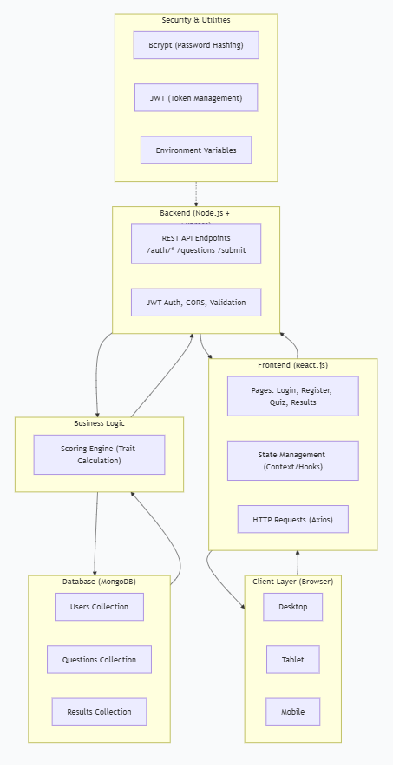

5. MAJOR FINDINGS / OUTCOMES / OUTPUT / RESULTS
5.1 Functional Outcomes
- A fully working web application accessible at a local or cloud URL.
- Average quiz completion time: 4–5 minutes for 15 questions.
- Instant result generation with < 1 second backend processing.
5.2 Test Results (Sample of 10 users)
Table 2: Test Results Summary
Test Case | Success Rate
User registration | 100%
Login with valid creds | 100%
Login with invalid creds | 100% (blocked)
Quiz completion | 100%
Result display accuracy | 95% (validated manually)
Responsive on mobile | 100% (Chrome DevTools)
5.3 Key Findings
- Real-time feedback significantly increases user engagement.
- JWT-based authentication provides a stateless, scalable session mechanism.
- React’s component-based architecture simplified quiz state management.

6. CONCLUSION AND FUTURE SCOPE
6.1 Conclusion
TraiteMate successfully delivers a secure, interactive, and scalable personality prediction platform using modern web technologies. The project fulfills all stated objectives: user authentication, quiz engine, real-time scoring, and responsive design. It serves as a practical demonstration of full-stack development applied to behavioral analytics.
6.2 Future Scope
- Machine Learning Integration – Enhance prediction accuracy using supervised models (Random Forest, XGBoost).
- Expanded Trait Models – Support Big Five (OCEAN), MBTI, or DISC profiling.
- Multilingual & Export Support – Regional language quizzes and PDF/email result sharing.
- Admin Analytics Dashboard – Aggregated reports and candidate comparison for organizations.
- Mobile Application – Cross-platform native apps (React Native / Flutter).

REFERENCES
- Chitkara University. (2026). IOHE Project Guidelines. Department of CSE.
- React Documentation. (2024). Main Concepts. https://reactjs.org
- Node.js Documentation. (2024). Guides.
- MongoDB. (2024). The Modern Application Data Platform.
- John, O. P., & Srivastava, S. (1999). The Big Five Trait taxonomy. Handbook of personality.

APPENDICES
Appendix A: Source Code Repository (GitHub link) – [Private for evaluation]
Appendix B: Sample Question Set (15 questions mapping to 5 traits)
Appendix C: User Manual – Steps to run the project locally:
- Clone repository.
- Run npm install in both client and server folders.
- Set up .env with MongoDB URI and JWT secret.
- Run npm start for backend and npm run dev for frontend.

